Quinn Knudsen

Homework 4

Topic: **Statistical Inference Part I**

7)

> summary(PlantGrowth)

weight group

Min. :3.590 ctrl:10

1st Qu.:4.550 trt1:10

Median :5.155 trt2:10

Mean :5.073

3rd Qu.:5.530

Max. :6.310

The summary shows a range of 3.59 to 6.31 for weight with a median value of 5.16 and a mean of 5.07. The majority of the data falls between 4.55 and 5.53 (the first and third quantiles). Each group (control, treatment 1 and treatment 2) have 10 observations.

> hist(PlantGrowth$weight[PlantGrowth$group=="ctrl"])

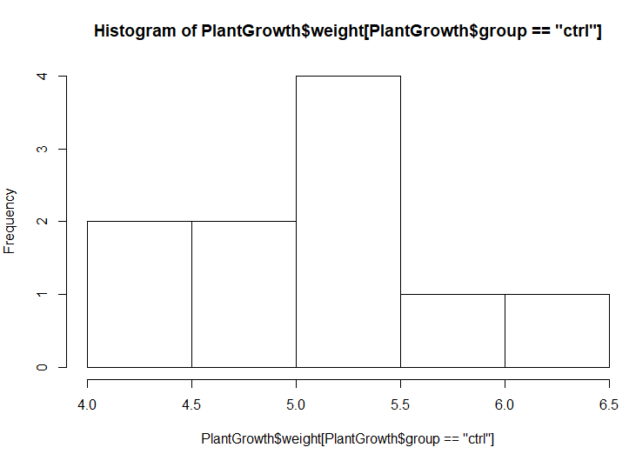

> hist(PlantGrowth$weight[PlantGrowth$group=="trt1"])

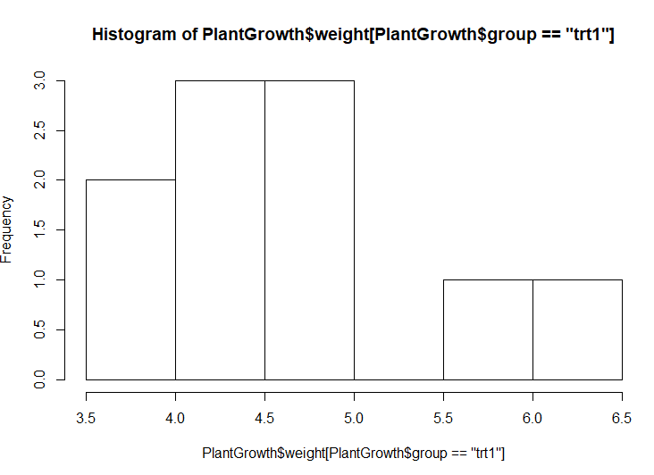

> hist(PlantGrowth$weight[PlantGrowth$group=="trt2"])

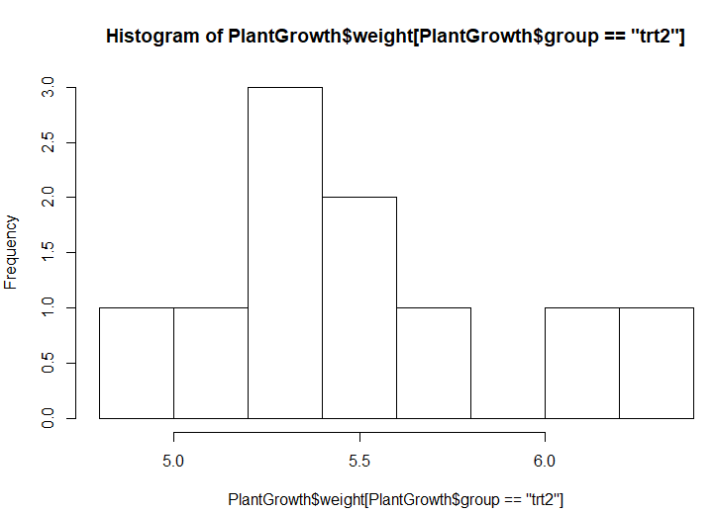

The low sample size presents a challenge, but treatment group number 1 appears to be the lowest with observed values less than 4.0 which will lower the mean and a relatively consistent spread when compared to the control group. The opposite can be said about treatment group 2 which appears to trend on the higher side with values more frequently above 6.

> mean(PlantGrowth$weight[PlantGrowth$group=="ctrl"])

[1] 5.032

> mean(PlantGrowth$weight[PlantGrowth$group=="trt1"])

[1] 4.661

> mean(PlantGrowth$weight[PlantGrowth$group=="trt2"])

[1] 5.526

Exploring the means confirms this initial graphic view of the data.

8)

> boxplot(PlantGrowth$weight ~ PlantGrowth$group)

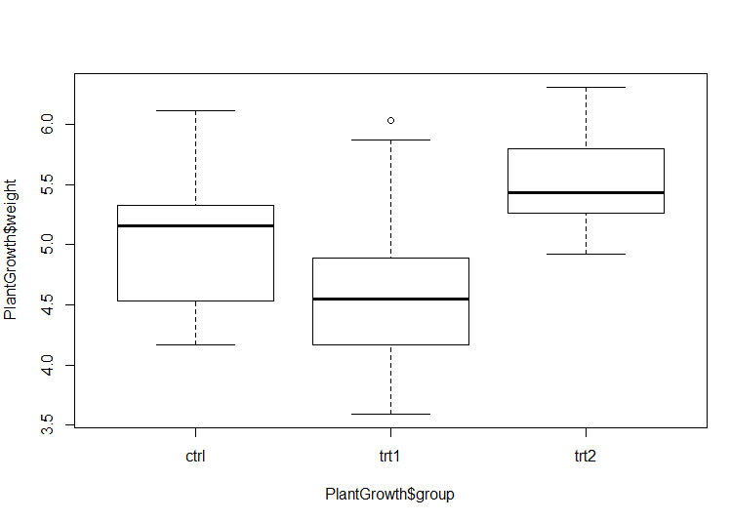

It is clear to see here that the median is lower in treatment group 1 and higher in treatment group 2 when compared with the control group. There is also an outlier impacting treatment group 1 that will actually increase the mean of the group. If imputing it would lower the mean of this group significantly.

9)

> t.test(PlantGrowth$weight[PlantGrowth$group=="ctrl"],PlantGrowth$weight[PlantGrowth$group=="trt1"])

Welch Two Sample t-test

data: PlantGrowth$weight[PlantGrowth$group == "ctrl"] and PlantGrowth$weight[PlantGrowth$group == "trt1"]

t = 1.1913, df = 16.524, p-value = 0.2504

alternative hypothesis: true difference in means is not equal to 0

95 percent confidence interval:

-0.2875162 1.0295162

sample estimates:

mean of x mean of y

5.032 4.661

We cannot conclude with appropriate statistical confidence that there is a difference between the means of the control group and treatment group 1. If we replicated 100 samples of this experiment, 25% would cross the ‘plane of 0’ indicating a non-significant finding. Based upon our sample, we cannot include that there would be an effect in the overall population of the two groups based upon our sample of 10 individuals in each condition. The confidence interval here (-.28 to 1.03) clearly across the 0 indicating a nonsignificant finding p=.2504. With 95% confidence the mean is both positive and negative indicating growth is indeterminant.

10)

> t.test(PlantGrowth$weight[PlantGrowth$group=="ctrl"],PlantGrowth$weight[PlantGrowth$group=="trt2"])

Welch Two Sample t-test

data: PlantGrowth$weight[PlantGrowth$group == "ctrl"] and PlantGrowth$weight[PlantGrowth$group == "trt2"]

t = -2.134, df = 16.786, p-value = 0.0479

alternative hypothesis: true difference in means is not equal to 0

95 percent confidence interval:

-0.98287213 -0.00512787

sample estimates:

mean of x mean of y

5.032 5.526

We can conclude with appropriate statistical confidence that there is a difference between the means of the control group and treatment group 2. If we replicated 100 samples of this experiment, 5% would cross the ‘plane of 0’ indicating a non-significant finding. Based upon our sample, we can include that there would be an effect in the overall population of the two groups based upon our sample of 10 individuals in each condition. It appears that treatment 2 will significantly increase plant weight (although it would be lovely to increase the sample size and control for other known variables that might influence this experiment including repeated measurement 😊). The confidence interval here remains negative (-.98 to .01) indicating an effect, however the strength of the effect could be quite small.